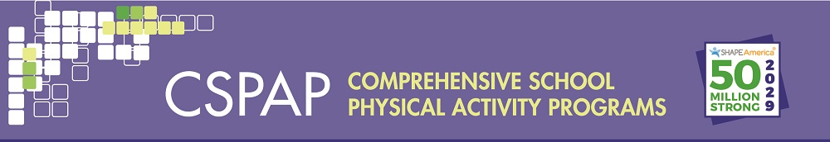
Table 2B.Developing Program Outcomes and Indicators-Youth Level
Youth Level
Vision | Goal | Objective | Outcome | Indicator(s)
 | Goal 1: | Objective: | Short/Intermediate/Long
 | Goal: | Objective: | Short/Intermediate/Long

